# CLOSED CURVE APPROXIMATION USING FOURIER DESCRIPTORS

**GOKARAJU RANGARAJU INSTITUTE OF ENGINEERING AND TECHNOLOGY**

Nakka Keerthana

ABSTRACT

The objective of this work is to extract boundary of the object using minimum number of descriptors possible. In this thesis, boundary of the object in the image is extracted and several approximations of the boundary are observed and compared.

In this work, the following results are demonstrated: -

1. Boundary is detected which describes the shape of the object.
2. Using complex shape signature, different approximations of the original boundary are done till the approximated boundary resembles the original boundary.
3. To improve the approximations using Fourier descriptors.

KEYWORDS

Centroid distance function, area function, curvature function, complex shape signature, mean, standard deviation.

INTRODUCTION

The technique of approximating a digital boundary using the least possible number of Fourier descriptors is called Closed Curve Approximation using Fourier Descriptors. By detecting good choice of boundary points on the digital boundary, one may be able to visibly recognize the shape of the curve.

Approximation is a general concept in medical field.

Medical imaging has been undergoing a revolution in the past decade with the advent of faster, more accurate, and less invasive devices. This has driven the need for corresponding software development, which in turn has provided a major impetus for new algorithms in signal and image processing.

LITERATURE SURVEY

The concept of Fourier descriptors is referred from [1], the concepts of shape signatures are referred from [2] & [3], the concept of Complex shape signature is referred from [4], the concept of Centroid Shape signature is referred from [5], the concept of Contour Curvature is referred from [6].

1 .METHODOLOGY

* 1. Conversion of gray-scale image to binary image

Initially the image of object is converted to binary image. This binary image is a digital image that has only one value for each pixel i.e. either ‘0’ or ‘1’. Typically the two colors used for a binary image are black and white. The color used for the object in the image is the foreground color while the rest of the image is the background color.

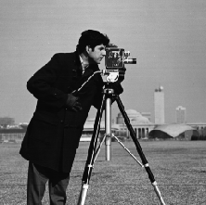 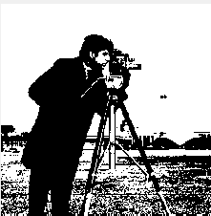

Figure 1.1.1: original image Figure 1.1.2 : binary image

1.2.Extraction of boundary

Boundary of the object in binary form of the original image is extracted using all the boundary descriptors. This can be done by using different shape signatures.

The one used in this study is Complex Shape Signature.

We trace the exterior boundaries of objects, as well as boundaries of holes inside these objects, in the binary image.

Then boundary is converted to an image by converting b, an np-by-2 or 2-by-np array representing the integer coordinates of a boundary, into a binary image with 1s in the locations defined by the coordinates in b and 0s elsewhere.

Finally the boundary is placed approximately centered in an M-by-N image. If any part of the boundary is outside the M-by-N rectangle, an error is issued.

So to avoid this, M and N must take the values of number of x-coordinates and y-coordinates present in the boundary respectively.

Once the original boundary is extracted, different approximations of the boundary are observed and compared to the target boundary.

This comparison of the approximations to the target boundary is done using mean and standard deviation concepts.

Firstly, mean (µ) and standard deviation (σ) of the target boundary is calculated. Let’s say the first approximation is A1

Find the mean of the first approximation, say µ1 using Fourier descriptors (say 5).

A threshold value, say λ is set to 9x10-5.

Computing

|(( µ1- µ)/x*σ)| for value of x ranging from 1.4 to 3 spacing 0.2 .

If the value computed is found to be less than λ, then A1 is a good approximation.

Else same Procedure is repeated for the next approximation.

For a given x and a given λ, the approximation which need not be further improved is found.

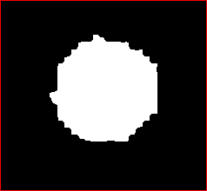 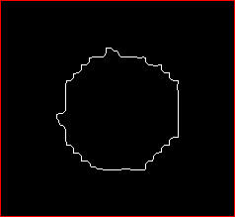

Figure1.2.1. Binary image Figure1.2.2.Extracted boundary

1.3.Shape Signatures

Fourier descriptors are derived from a shape signature. In general, a shape signature u(t) is any 1-D function representing 2-D areas or boundaries.

1.3.1.Centroid Distance

The centroid distance function is expressed by the distance of the boundary points from the centroid (xc, yc) of the shape

r(t)= ([x(t) - xc]2 + [y(t) - yc]2)1/2

r(t) is invariant to translation. Computation of r(t) is low.

1.3.2.Area Function

When the boundary points change along the shape’s boundary, the area of the triangle formed by the two boundary points and the centre of gravity will also tend to change.This forms an area function which can be claimed as shape representation

1.3.3.Curvature signature

Curvature is a very important boundary feature for human to judge similarity between shapes. Curvature function is defined by

K(t)=dw/dt

Where w is boundary tangent angle.

Although curvature is a very important feature, there is a problem for curvature feature as a shape representation. For many digital curves, especially for polygonal curve, w(t) is a step function, so k(t) is zero almost everywhere and infinite at discrete jumps of w(t). This makes k(t) a poor candidate for shape representation. In order to use k(t) for shape representation, a smooth curvature function should be derived.

1.3.4.Complex shape signature

Consider a k-point digital boundary in the xy-plane, starting at an arbitrary point, (x0, y0), consecutive coordinate points are encountered in traversing the boundary, say, in the counterclockwise direction.

These coordinates can be expressed in the form x(k)=xk and y(k)=yk. With this notation, the boundary itself can be represented as the sequence of coordinates s(k)=[ x(k), y(k)], for k=0,1,2…..,K-1. Moreover, each coordinate pair can be expressed as complex number so that

s(k)=x(k) + y(k)

The discrete Fourier transform of 1-D sequence s(k) can be written as

a(µ)= ∑s(k)e-j2πµk/K  from k=0 to K-1.

for µ=0,1,2,……,K-1. The complex coefficients a(µ) are called the fourier descriptors of the boundary. The inverse Fourier transform of these coefficients restores s(k). That is

s(k)=∑a(µ) ej2πµk/K from µ =0 to K-1.

for k=0,1,2,……,K-1. Suppose however, that instead of all fourier coefficients we use the first P coefficients ion computing the inverse. This is equivalent to setting a(µ)=0 for µ > P-1 in the preceeding equation for a(µ).

The result is the following approximation to s(k).

s1(k)=∑a(µ) ej2πµ/K from µ =0 to P-1.

1.3.5.Mean

Matrix elements of an image are its pixel values. Mean of an image is calculated by adding all its pixel values and the sum is divided by the total number of pixels.

1.3.6.Standard Deviation

Firstly, the mean of an image is calculated and is subtracted from each pixel value. Now, obtained elements of the matrix are squared and are added. Finally, the sum obtained is divided by the total number of pixels to get variance.

Square root of the variance obtained is termed as the standard deviation of the image.

1.3.7.Description

Now, P(mentioned in 1.3.4) is set to 5, approximated boundary for the Figure1.2.2 is as shown

 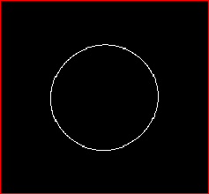 Figure1.3.7.1.Target boundary Figure1.3.7.2: Approximation using 5 descriptors

Further this approximation can be improved by increasing the number of descriptors.

The difference in the mean values of the target boundary and the approximated boundary is calculated

Now, P is set to 10, next approximated boundary for the figure1.2.2 is as shown

 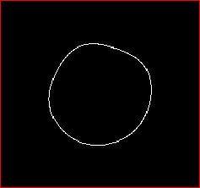

Figure1.3.7.3. Target boundary Figure1.3.7.4. Approximation using 10 descriptors

2.CASE STUDIES

2.1.Cloud image



Figure2.1.1: cloud image

This image has 832 boundary points and so has 832 descriptors. Initially boundary is extracted using all the descriptors.

Computing

|(( µ1- µ)/x*σ)| for value of x ranging from 1.4 to 3 spacing 0.2 .

For x=1 and perfect approximation of the boundary is obtained.

The total number of descriptors used in the reconstruction of the boundary is 315.

For the best reconstruction, atmost corner points should be used, as corner points have high curvature.

Corner points of the original boundary are 101 while corner points of the reconstructed boundary are 100.

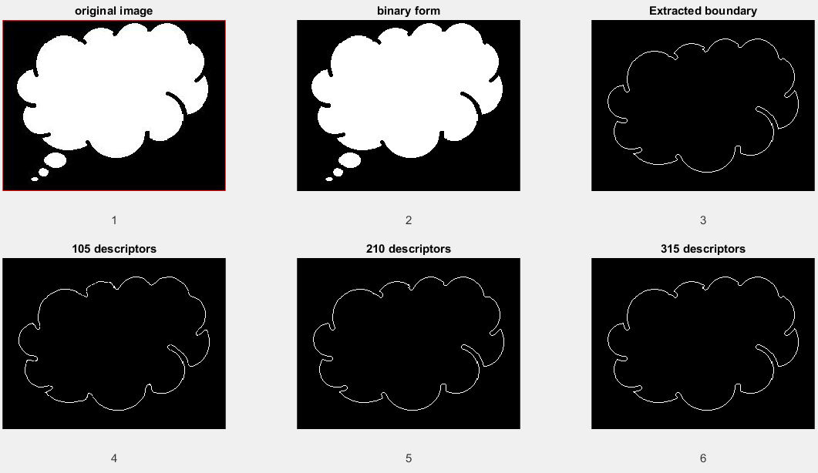

Figure2.1.2: Gradual improvement in the approximation

For x=1.6 and using 315 descriptors, the ratio |(( µj- µ)/x*σ)| becomes less than λ.

So this number of descriptors is used for the first best approximation.

Where µj=mean of the jth approximation.

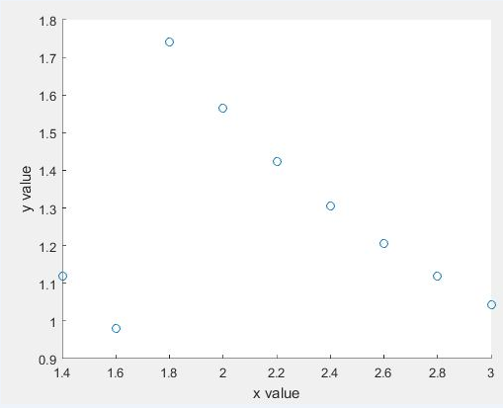

Figure 2.1.3: =|(( µj- µ)/x*σ)|/ λ vs x plot for cloud image

Here y=|(( µj- µ)/x*σ)|/ λ is plotted against x value which ranges from 1.4 to 3 with a step of 0.2 as mentioned earlier.

And the minimum is found at x=1.6 for which the first best approximation is obtained.

2.2.Dinosaur

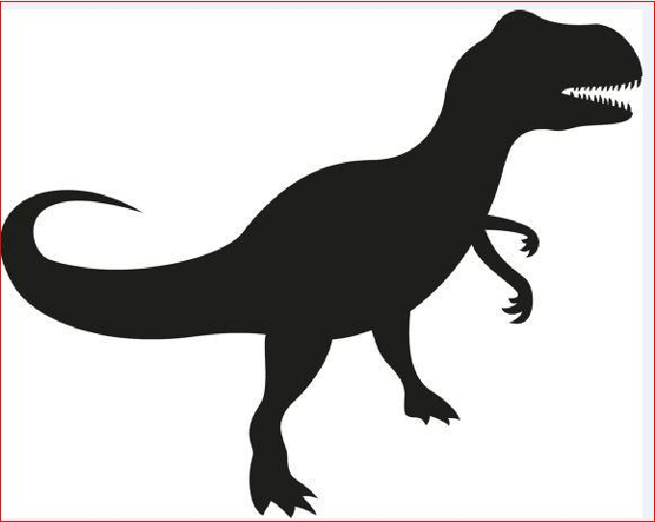

Figure 2.2.1: Dinosaur image

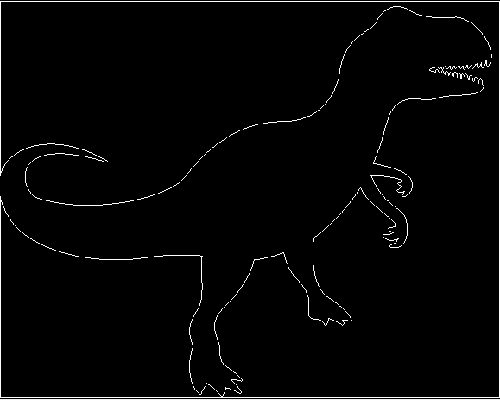

Figure 2.2.2: Target boundary

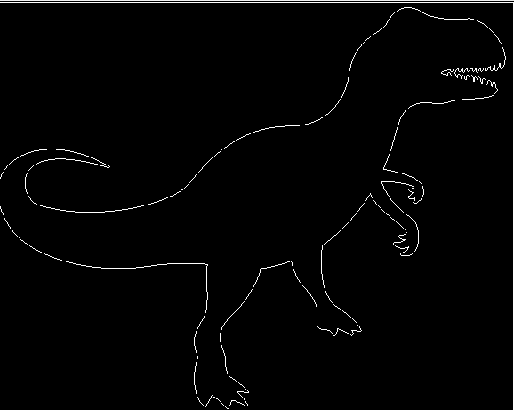

Figure 2.2.3: Approximation using 2000 descriptors

Actual number of descriptors of the target boundary is 4660.

.For x=1.4 and using 2000 descriptors, the first best approximation of the target boundary is obtained.

Improvement in the boundary, particularly improvement in the teeth of dinosaur is observed.

2.3.Lizard

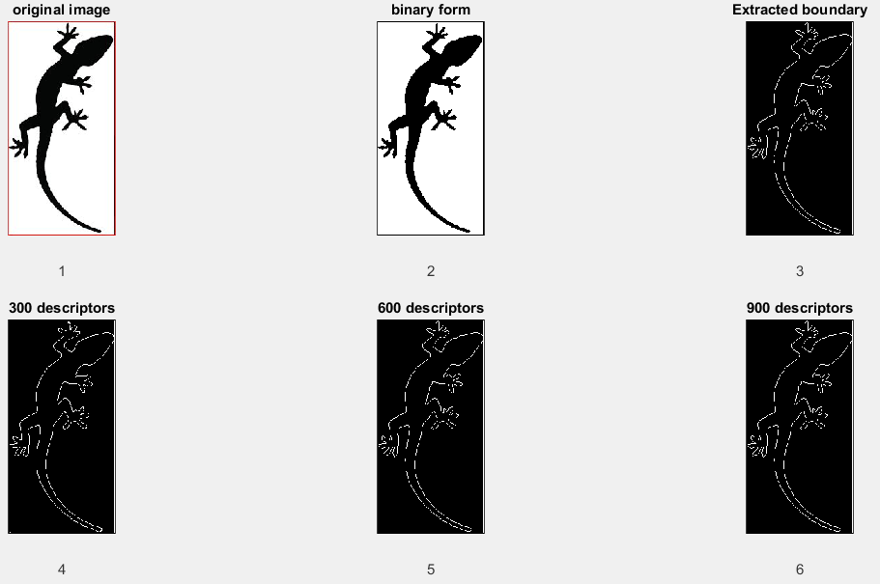

Figure2.3.1. Boundary approximation of a lizard image

For x=1.4 and using 900 descriptors, the first best approximation of the target boundary is obtained while the actual number of descriptors is 2271.

3.MEDICAL IMAGES

3.1. Palm

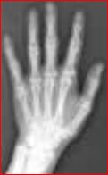 

Figure3.1.1: X-ray of palm Figure3.1.2: binary form

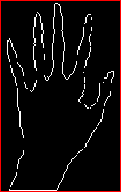

Figure3.1.3: Extracted boundary

Approximation is started with 5 descriptors and is compared to the original extracted boundary.

 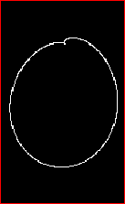

Figure 3.1.4: Target boundary Figure 3.1.5:Approximation using 5 descriptors

 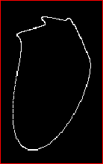

Figure 3.1.6: Target boundary Figure3.1.7:approximation using 10 descriptors

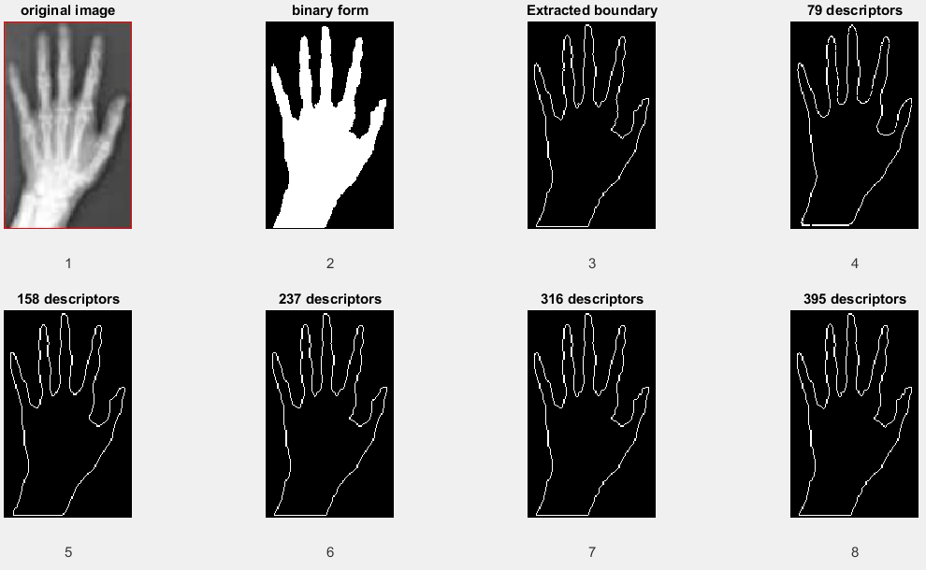

Figure3.1.6: Gradual improvement in the approximated boundaries.

Original X-ray image of palm has 911 boundary points and so has 911 descriptors .

Corner points of the target boundary are 109 in number.

For k=2.6 and using 395 descriptors, the first best approximation of the target boundary is obtained.

And total number of corner points in this approximation are 107.

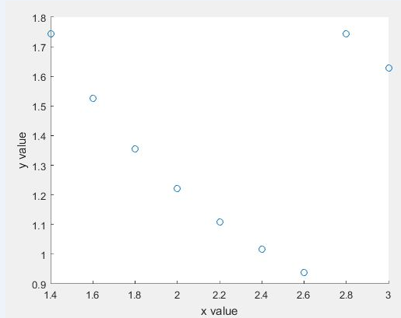

Figure 3.1.7: |(( µj- µ)/x*σ)|/ λ vs x plot for x-ray of hand

Here y=|(( µj- µ)/x*σ)|/ λ is plotted against x value which ranges from 1.4 to 3 with a step of 0.2 as mentioned earlier.

And the minimum is found at x=2.6 for which the first best approximation is obtained.

3.2.Database of images.

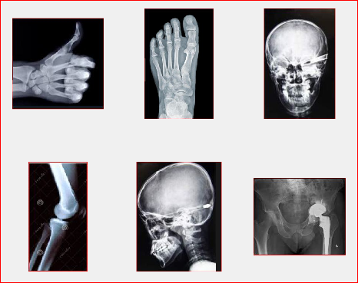

Figure3.2.1: Database of different medical X-ray images

3.2.1.X-ray of Wrist

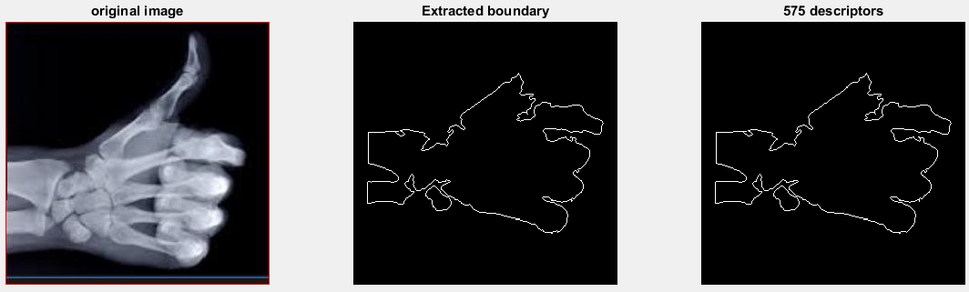

Figure 3.2.1.1: Comparison of the best approximation to the target boundary.

Target boundary has a total of 1233 descriptors and 158 corner points.

For x=2.4 and using 575 descriptors, the first best approximation of the target boundary is obtained. Corner points in this approximation are 154.

3.2.2. X-ray of foot

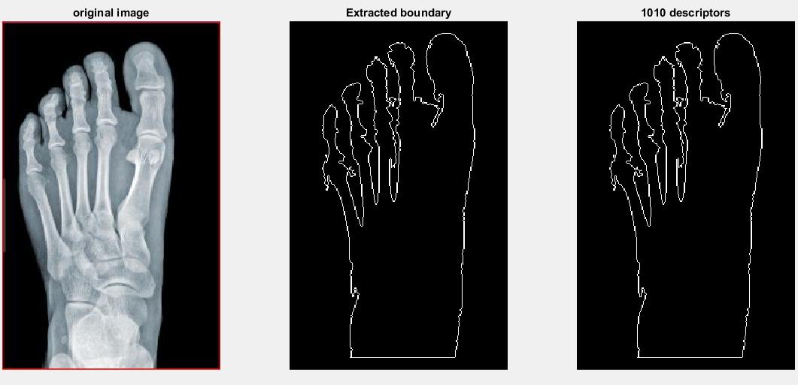

Figure 3.2.1.2: Comparison of the best approximation to the target boundary.

Target boundary has a total of 2105 descriptors and 200 corner points.

For x=2.6 and using 1010 descriptors, the first best approximation of the target boundary is obtained. Corner points in this approximation are 200.

3.2.3. X-ray of skull (front view)

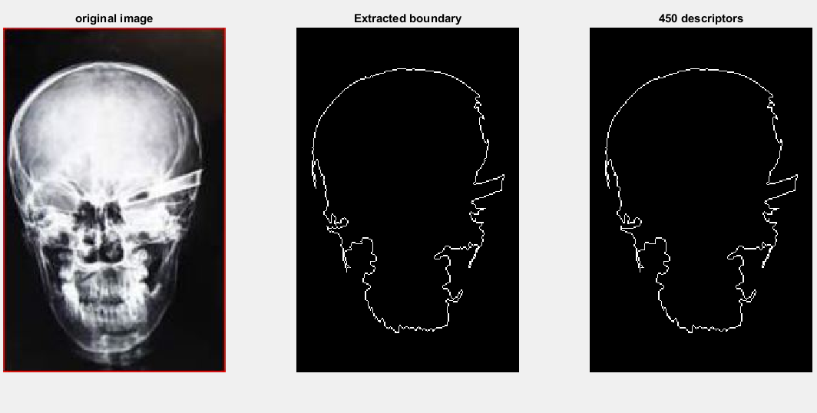Figure 3.2.1.3: Comparison of the best approximation to the target boundary.

Target boundary has a total of 1001 descriptors and 133 corner points.

For x=1.4 and using 450 descriptors, the first best approximation of the target boundary is obtained. Corner points in this approximation are 129.

3.2.4. X-ray of bone

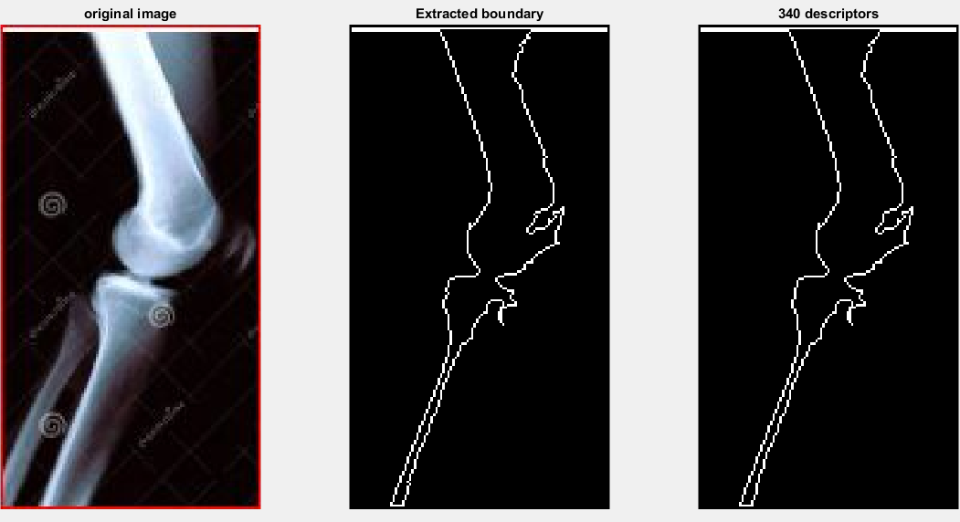

Figure 3.2.1.1: Comparison of the best approximation to the target boundary.

Target boundary has a total of 674 descriptors and 63 corner points.

For x=3 and using 340 descriptors, the first best approximation of the target boundary is obtained. Corner points in this approximation are 62.

3.2.5. X-ray of skull (side view)

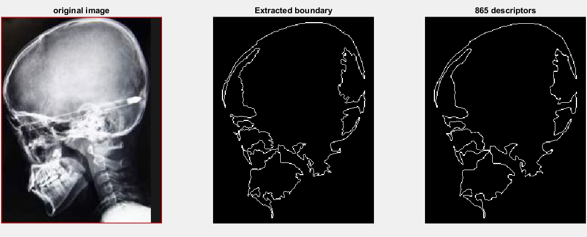Figure 3.2.1.4: Comparison of the best approximation to the target boundary.

Target boundary has a total of 1998 descriptors and 200 corner points.

For x=3 and using 865 descriptors, the first best approximation of the target boundary is obtained. Corner points in this approximation are 200.

3.2.6. X-ray of a diseased area

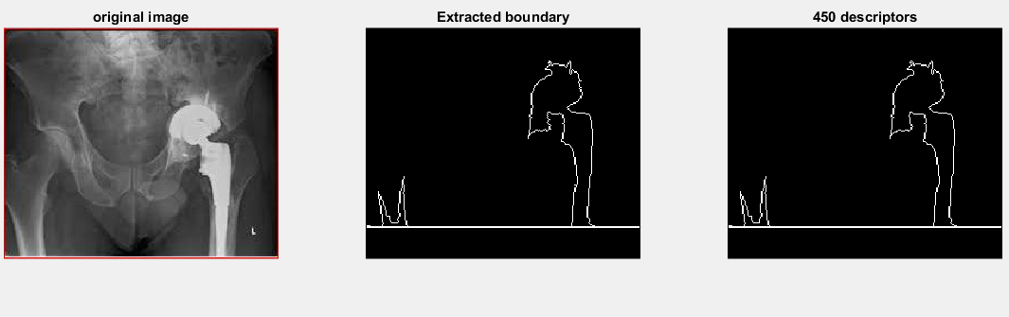

Figure 3.2.1.6: Comparison of the best approximation to the target boundary.

Target boundary has a total of 1037 descriptors and 71 corner points.

For x=1.8 and using 450 descriptors, the first best approximation of the target boundary is obtained. Corner points in this approximation are 70.

CONCLUSION

Basically the task of reduction which is referred to as approximation, is done to suppress the irrelevant information. Perfect boundary of an object can be extracted if all its descriptors are used. But for computer processing purpose, it is advantageous if the reconstruction of the object is done with fewer descriptors without the loss of shape.

REFERENCES

[1] FOURIER DESCRIPTORS FOR PLANE CLOSED CURVES

-CHARLES T.ZAHN AND RALPH Z. ROSKIES

[2] A COMPARATIVE STUDY OF FOURIER DESCRIPTORS FOR SHAPE REPRESENTATION AND RETRIEVAL

-DENGSHENG ZHANG AND GUOJUN LU

[3] SHAPE DISCRIMINATION USING FOURIER DESCRIPTORS

-ERIC PERSOON, MEMBER, IEEE, AND KING-SUN FU, FELLOW, IEEE

[4] DIGITAL IMAGE PROCESSING USING MATLAB

-Rafael C.Gonzalez

-Richard E.Woods

-Steven L.Eddins

[5] CENTROID DISTANCE FUNCTION AND THE FOURIER DESCRIPTORS APPLICATIONS TO CANCER CELLS

-Swathi Bhonsle and Alissa Klinzmann

[6] SHAPE DESCRIPTOR/FEATURE EXTRACTION TECHNIQUES

-Fred Park